**Display Date and Time Using**

**Real Time Clock (RTC)**

**Description:**

This Project is to display **Date and Time** using **Real Time Clock (RTC)** on a **LCD (16x2) display**. The RTC module is used to keep **track of the time** even when the Arduino board is **powered off**. The time data from the **RTC module** is then displayed on the **LCD display** using **I2C communication**. A library is used to simplify the code and make it easier to work with the RTC and LCD components. The **date and time** in the code can be **adjusted** before uploading it to the board to **ensure** that the **correct time is displayed**.

**Block Diagram:**

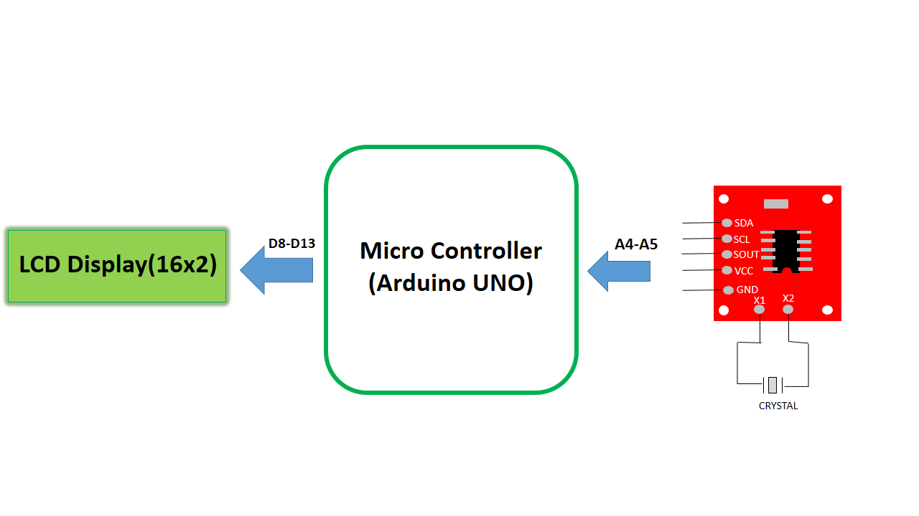

**Inputs and Outputs:**

|  |  |  |  |  |  |  |
| --- | --- | --- | --- | --- | --- | --- |
| **S.No** | **Description** | **Name** | **Type** | **Data Direction** | **Spec** | **Remarks** |
| 1 | Serial Data | SDA | INP | DI | 5VDC | Active High |
| 2 | Serial Clock | SCL | INP | DI | 5VDC | Active High |
| 3 | LCD Reset Pin | RS | OUT | DO | 5VDC | Active High |
| 4 | LCD Enable Pin | E | OUT | DO | 5VDC | Active High |
| 5 | LCD Data Pin 1 | D4 | OUT | DO | 5VDC | Active High |
| 6 | LCD Data Pin 2 | D5 | OUT | DO | 5VDC | Active High |
| 7 | LCD Data Pin 3 | D6 | OUT | DO | 5VDC | Active High |
| 8 | LCD Data Pin 4 | D7 | OUT | DO | 5VDC | Active High |

**Flow Chart:**

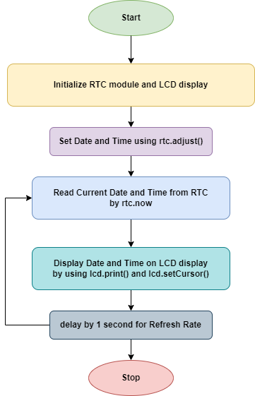

**The END**